**Opening a IRA**

1. From the Dashboard on the left hand side under assigned services click on “Nu Account Console”

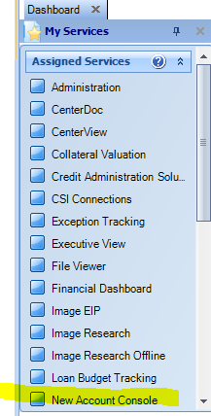

1. Under “Action” on the left click “Start a New Session”

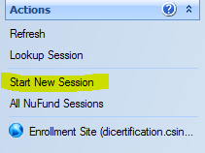

1. At the top of page on the search field, search for customer, “last name, first name”

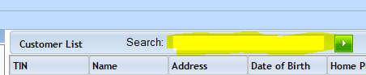

1. Double click the desired customer’s name. This will add the customer to session on left hand side of the page under “View Summary Session”

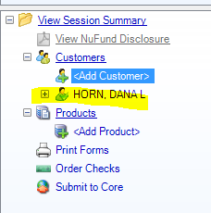

1. Click “Next” on bottom of page. The customer information will populate on the next screen.

Scroll through this information to verify that is correct.

The top section will be the CIF information

The next section will be the Bank Information

The next section will be the demographic section.

If you make changes here they will be applied to that CD only.

1. Once you have verified this information click “Next” on the bottom of the screen
2. This will take you to the OFAC look up screen. Click the green arrow on the top portion of the screen this will give you the OFAC results.
3. Click “Next” to take you to the product page
4. On the product page find the CD or IRA section (if that section is closed, click on the + to open)

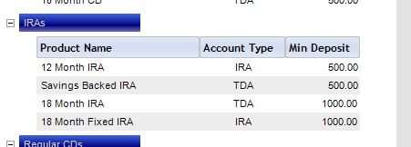

1. Choose the desired product by double clicking that product. This will add the product to your session on the left hand side.

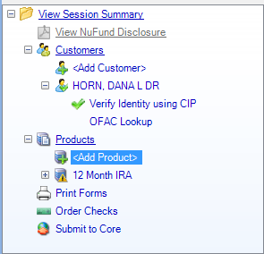

1. Click “Next” on bottom of screen
2. This will bring up the customer number field, on the right side click the “Generate” Button to generate a customer number

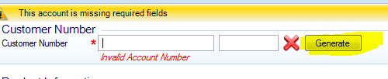

1. Once the customer number has been generated copy that number into the account number field, clear out the Customer Number field, this will be a bank defined field.
2. Tab down to “opening Balance” and put in the amount of the new IRA
3. Hit Tab – this should prefill your interest rate. Verify that it is correct.
4. Money source – using the drop down menu choose the correct money source
5. Ownership type – using the drop down menu choose the correct ownership type.

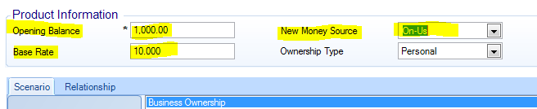

1. Under the relationship tab – there will be drops down box, under that drop down choose the correct name. This will pre fill the information in the boxes below

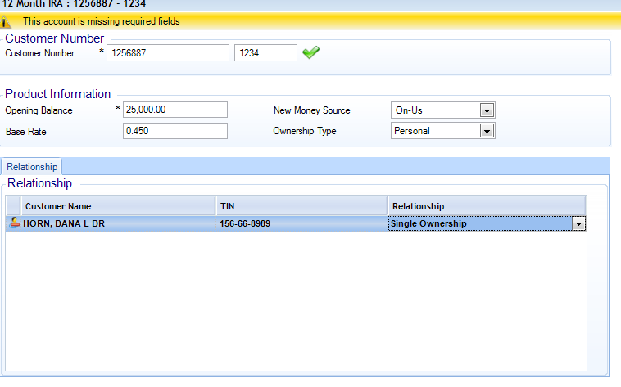

1. Review the CIF info in the top section
2. Review the account information in the next section
3. Under “additional information” the 5th box down will be the “Disposition” box – this will determine what will happen with the interest from the CD. From the drop down box choose the appropriate disposition.
   1. If you choose transfer to DDA or SAV – in the next box titled “Disposition Account” put the account number that the interest will be transferred to

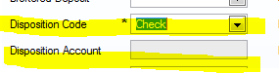

1. Scroll through the rest of the information and verify
2. Click “Next” – this will bring a Name and Address screen to verify.
3. Click “Next”
4. This will bring up your forms. On the left hand side will be forms that are required by your bank. On the right will be forms that are available to use. You can drag the forms from the right to left as desired.
5. Click “Next”
6. This will bring up your forms, verify and enter any information click next and print forms.
7. Click “Next
8. Click “Submit to core” at this point you will not be able to go back and change any information.
9. If all is input correctly you should get a screen that says “ All products submitted successfully”
10. At this point you should take the currency, check or whatever the customer is using to open the CD with to the teller line along with a general ledger credit with your CD control general ledger number to the teller line to be processed.

