Automatic Payment or Direct Deposit Switch Form
Use this form to redirect your automatic payments or direct deposit to your new bankcda account

Company Name: ________________________________________________

Mailing Address: ________________________________________________

________________________________________________

To Whom It May Concern:
My information is as follows:

Name: ____________________________ Phone Number: __________________________
Address: ____________________________________________________________________
Account Number with your Company: _____________________________________________

Please redirect my: ___ Direct Deposit ___ Automatic Payment
Effective: ___ Immediately ___ Beginning ____/____/____

My account information: ___ Checking ___ Savings ____ Money Market

bankcda account number: ___________________________________
bankcda ABA routing number: 123103826
bankcda contact information: bankcda
912 Northwest Blvd
Coeur d’Alene, ID 83814
208-665-5999

__________________________________ ___________________________________
Signature Signature of bankcda Representative

__________________________________ ___________________________________
Date Name / Telephone Number

___________________________________
Job Title

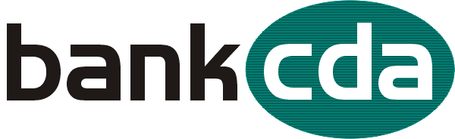

912 Northwest Blvd, Coeur d’Alene 200 W Honeysuckle Avenue, Hayden
208-665-5999 208-762-4492
www.bankcda.com Member FDIC

