**CSI Wire FAQs**

**Q: Do I reach out to the CRC for support?**

A: At this time, do **not** open a case with the CRC for assistance with CSI wire. Please email the wire transition group at Onboarding - CSI Wire [99c10d16.csiweb.com@amer.teams.ms](mailto:99c10d16.csiweb.com@amer.teams.ms). Any specifics regarding your question and error screenshots are extremely useful.

**Q: I get an error when I try to update notification settings. How can I correct this?**

A: This item will be corrected, but to correct manually, go to Administration > Settings > Notifications. From the notifications tab enable both inbound and outbound notifications. There is a blank email line populated. Click the “x” to remove the blank line for both. Save the changes and then make any adjustments needed.

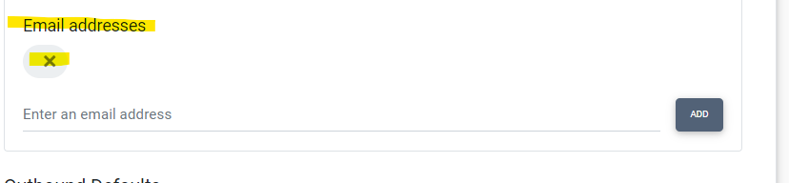

**Q: Can I assign multiple roles to one user?**

**A:** Each user can be assigned one role. A wire administrator can add additional roles with user specific privileges. There is not a limit to the number of custom roles created in CSI Wire.

**Q: What format for FMS/GL account numbers?**

CSI Wire will parse the FMS account number to separate the account number from the department code. This is a CSI managed setting and was set using your existing IGL settings.

Example: The department code setting is set to 2. For FMS account listed as 9123456789, the number string will be split with the last two digits being the department code: 91234567-89. This format will apply to all FMS account including settlement endpoints. If you have questions regarding your FMS account number format, please let us know.

**Q: An employee’s name or email address is blank or listed incorrectly. Who can update this information?**

A: This information is being populated by your bank’s active directory. The user/group that manages your bank’s network users will be able to update the active directory information for each user. This most likely will be your IT department or a 3rd parry IT vendor.

**Q: I have a user that does not have Learning Hub access. How do I get access added?**

A: Each institution has designated admins in the CSI Learning Hub and they can add access for a specific user.

**Q: I bookmarked CSI Wire but the saved bookmark is not working. What is the issue?**

A: Ensure that the bookmark is the CSI Wire site and not the redirect site to validate your user using   
CSI Identity. <https://csiwire.csiweb.com>

**Q: Is there a tile to access CSI Wire in NuPoint?**

A: Currently there is not a tile to access CSI Wire via NuPoint. The application is available via your preferred web browser.

**Q: Why do all users receive an error when attempting to access Templates from the Wire menu?**

A: The templates privilege will need to be added to any role that will need access to that feature. Navigate to Administration > Roles and for each role that requires templates access, select the privilege tab and add “Manage Wire Templates”

**Q: Will additional reports be available?**

A: Yes, we will develop additional reports in CSI Wire. The information from CSI Wire will also be available in CSI IQ for a custom reporting. This item is currently in active development.

**Q: Will the bank continue to have access to WDW after moving to CSI Wire?**

A: Yes, for audit and research purposes access to WDW will be available after transitioning to CSI Wire.

**Q: What needs to occur prior to starting to process wires using CSI Wire**?

A: For existing WDW banks, notify your wire implementations rep at a minimum **one business day** prior to processing wires in CSI Wire.

* Since CSI Wire creates the appropriate offsetting transactions to FMS/GL accounts instead of using IGL to create those offset as WDW does today, an adjustment to IGL settings for wire posting will need to be submitted

**Q: Will there be training resources for Exporting Wires?**

A: A video will be published in the Learning Hub focused on Exporting Wire(s). The session will include the new multi-wire export functionality and new Ready to Export tile for outbound wires. All new features will be added to the Learning Hub as they are released.

We will continue to add to this list and include the updated list in a weekly email.