**OPENING A NEW SAFE DEPOSIT BOX IN NUACCOUNT CONSOLE**

1. Each box that is available will be listed as “vacant” , under the CIF file listed as “Vacant’
2. Before opening a safe deposit box, you must “BREAK” or Unlink the box from the CIF file
3. Inquire on the box number
4. Once the box is shown in the screen, you will need to “lookup related customers”. You can do this by clicking on the “Lookup” related customers on the left of the screen

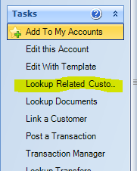

1. After you have accessed the related customer, it will appear as   
   “vacant Box” on the Screen. The ‘Unlink this Account” will be gray on the left side of screen. Once you click the “Vacant Box” the “Unlinked this Account” will turn black. Click the “Unlink this Account” and answer the popup with a “Yes.
2. At this point go to the “NuAccount Console” “Add New Product” scroll through the product list and find and choose the correct size of safe deposit box by double clicking, this will add the box to the session
3. Enter box number and tab, this should bring up a green check mark to verify that the box number is available
4. Click the drop down box under relationship, i.e... personal and this will prefill the info below
5. Click next and print forms
6. Submit to core