**Online Banking Statement Overview**

1. Customer logs into online banking and selects one of their checking or savings accounts.
2. Customer goes to statement tab for the selected account.
3. All customers that have not previously signed up for this service will be shown the estatement consent/agreement form. Customers must sign up for each account they have with the bank that they wish to receive statements for via online banking.
4. They will read the consent/agreement.
5. They will select the bubble titled “accept” indicating they accept the terms of this service.

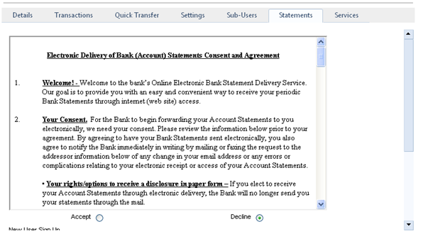

1. Customer will be prompted to fill in name and email address.

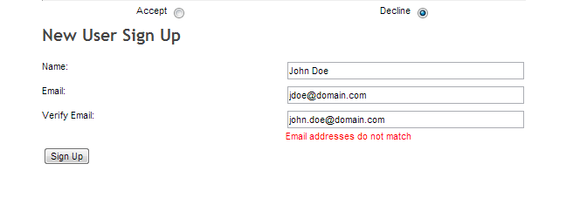

1. They hit the signup button located at the bottom.
2. Customer will be thanked for registering and will be told there are no statements available at this time. No statements will be available to the customer until 1)the maintenance is performed in NuPoint and 2)a statement has cut on the CSI system AFTER the maintenance.

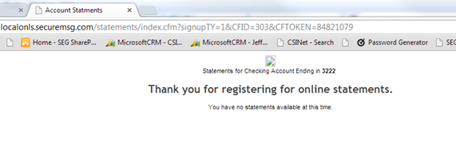

1. As soon as a customer signs up for this service within online banking, the information they filled in will be listed immediately on a report titled *Online Statements Registration Report*.
2. The bank pulls this report out of their eSafe admin account.
3. To get to this online statement registration report the bank would:
   1. Go to [www.csiesafe.com](http://www.csiesafe.com)
   2. Enter the username & password for the eSafe admin account.
   3. Go to the “My Account” tab that runs across the top.
   4. Click on the “reports” tab in the second row of tabs.
   5. Locate the area at the top of the screen that says “Online Statements Registration Report.”
   6. Select the date range in which you want to see sign ups for. For example if you select March 30th through April 30th, the report will show you ALL customers that signed up for this service in internet banking between March 30th and April 30th.

NOTE: The report will continue building forever and customers will never be deleted. Meaning you can always go back and pull a begin date as far back as you would like to see signups for.

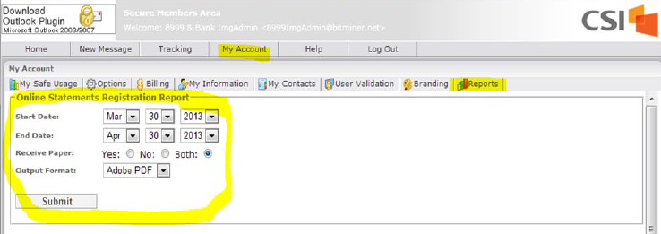

1. OPTIONAL SETUP: For a bank to receive an email each time an account is added to the Online Statements Registration report, the bank would do the following:
   1. Setup a regular email account to match the username on the esafe admin account.
   2. Only if a regular email account exists, each time an account is added to the report an email will go to the regular email account alerting of the signup. Customer info will be limited since it will be coming through in an email. Name, email address, last four digits of account number, and last four digits of TIN will be provided.
2. For each account that has signed up in internet banking, the bank must perform maintenance to that account in the Nupoint System before the statement will start being delivered that way.
3. To perform this maintenance in the Nupoint system:
   1. Inquire on the dda or savings account
   2. Select setup email info from the task menu on the left
   3. Select “Internet Banking Stmt Only” or your desired variation of that in the “email enabled account” field
   4. Enter an email address in the email address field.

NOTE: ONLY the two fields stated above are required on that screen. All other fields are optional.

* 1. No statement will show up in online banking until their next statement cuts. Then statements from that time forward will start going to online banking.

1. Each time a statement is delivered to online banking for viewing, a regular email goes to the customer’s email address(if there is one stored in the email address field in Nupoint).
   1. We have a generic email that goes out that says “Your statement has now been delivered to online banking. Please log into online banking to view.”
   2. The bank can customize this if they choose to from within the eSafe admin account.
2. Before the customer can view their first statement in online banking, they must go through a verification process. This process confirms they are capable of viewing a PDF through an internet browser. They will see the below screen.

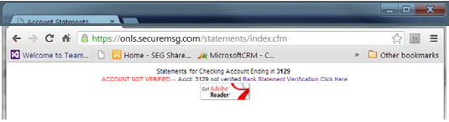

1. They will follow the instructions by clicking where they are directed to click.
2. They will read the following text and click once more to finalize the verification process.
3. If they are unable to pass through the verification process, troubleshooting efforts should begin to determine PDF viewing issues within an internet browser.
4. The bank can pull a Verification report out of the eSafe admin account on the My Account tab and Reports subtab.

