**P2P Instructions**:

Limits are bank defined and are in place. To change bank default limits, please reach out to Digital Banking Support.

To enable P2P on a customer, search and edit the customer in the IB Admin site. Click on the Checking tab and check “P2P Enabled” for each account that needs access to P2P:

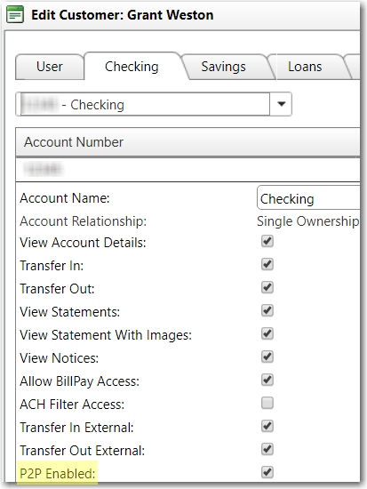

Limits can be adjusted per customer by editing the customer in IB Admin and looking at the User tab for “Override Card Transfer Maximum”. Once you check “Override Card Transfer Maximum”, the limit fields become editable:

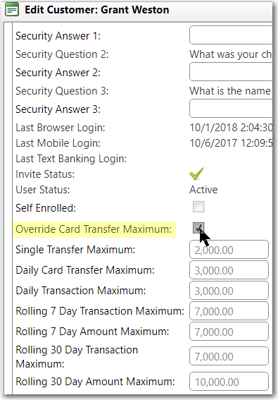

Once the customer logs in after being enabled, they will have a new option when adding payees from the My Payees screen OR by initiating a New Transaction and choosing “+ Add New Payee” on the Recipient screen:

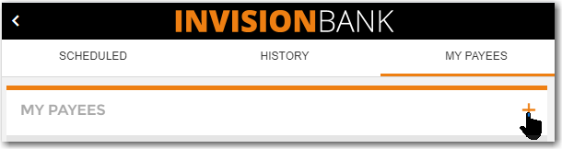

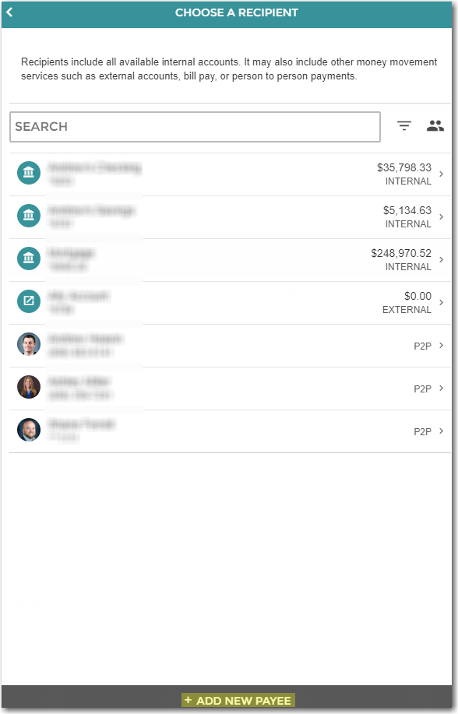

They will select “Person To Person” on the Add New Payee screen and then enter the Payee information:

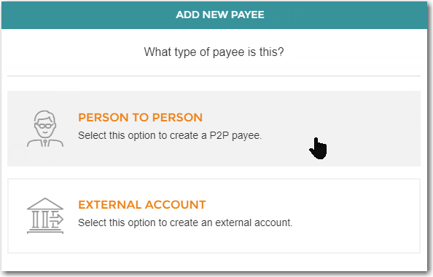

When entering Payee info, the customer has 3 options:

1. Enter Payee’s card info or have payee enter card info into their phone

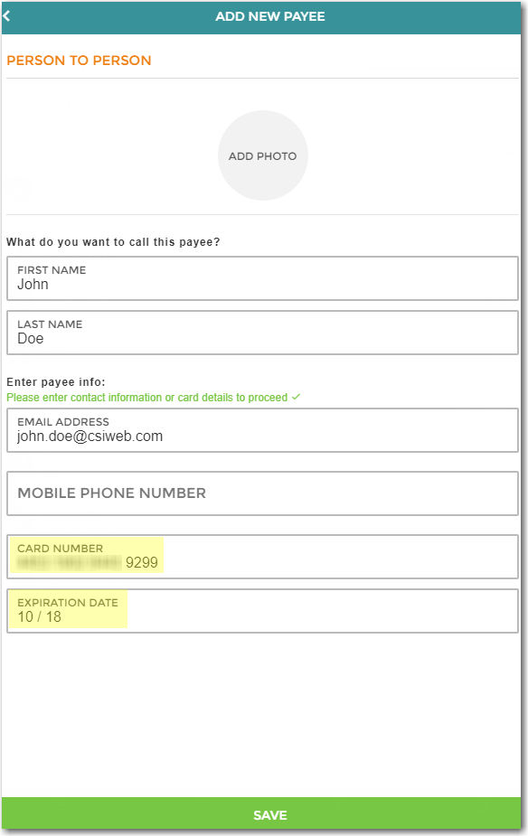

1. Enter Payee’s email and an email will be sent to payee asking them to enter their card info:

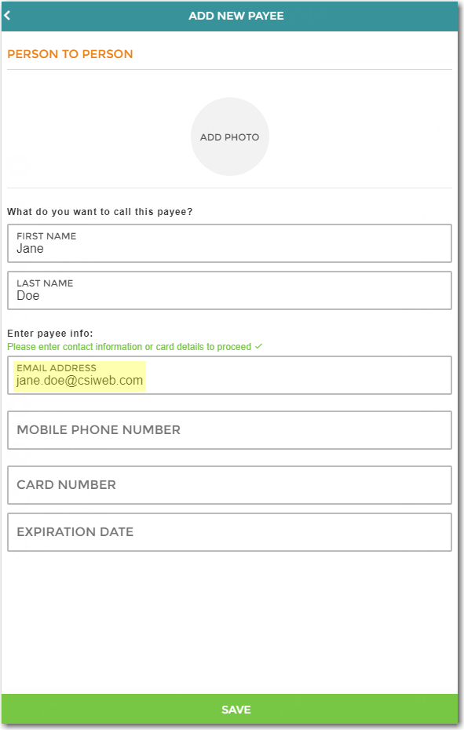

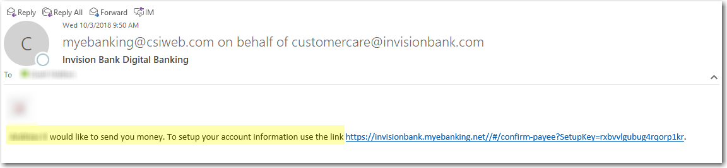

1. Enter Payee’s phone number to send them a text asking them to enter their Card info:

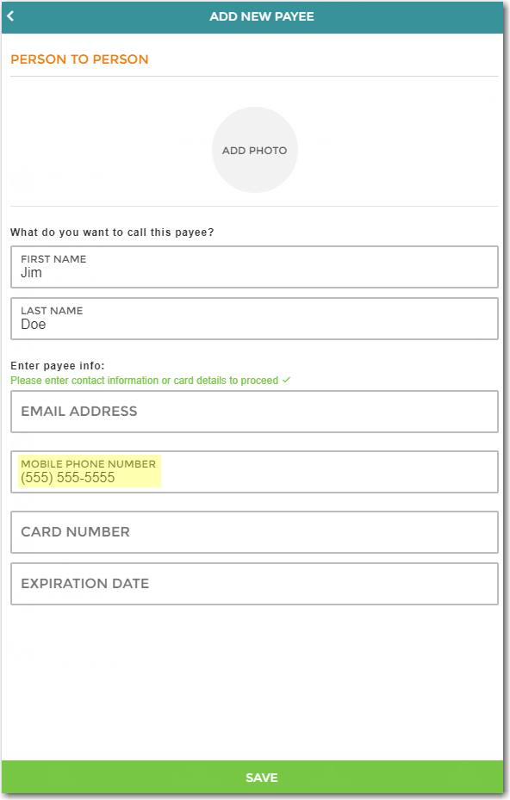

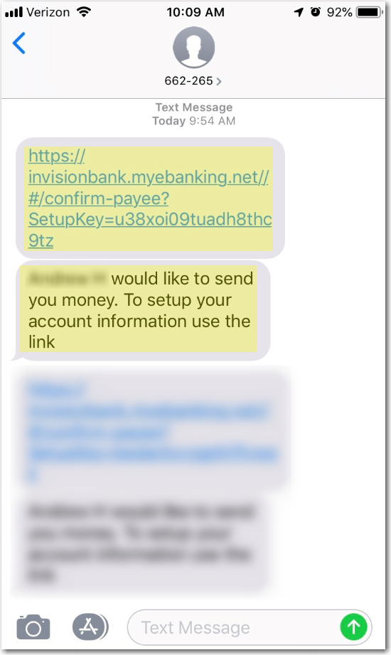

Once all required info is entered by the recipient, you are ready to send money by going to New Transaction and choosing the newly created Payee from the Recipient list. You do have an option to choose how the Payee is notified of the payment:

